Thermophysical Properties of Deep Eutectic Solvent-Carbon Nanotubes (DES-CNT) based nanolubricant
Rashmi Walvekar^{1*} Amarpreet Singh¹, Mohammad Khalid², TCSM Gupta ³, Wong Wai Yin⁴
¹Taylor’s University, Jalan Taylor’s, Subang Jaya, 47500 Selangor, Malaysia
²Research Centre for Nano-materials and Energy Technology, School of Science and Technology, Sunway University, No. 5, Jalan Universiti, Bandar Sunway, 47500 Subang Jaya, Selangor, Malaysia
³Research and Development, Apar Industries Limited, Mumbai, India
⁴University Kebangsaan Malaysia, Bangi, 43600 Selangor, Malaysia

*rashmi.walvekar@gmail.com

Abstract
Lubrication is an important aspect when it comes to machinery and equipment in the industry where nanolubricants are extensively being explored as the future of lubricants. Nanolubricants are new-engineered fluids, which are dispersed with nanoparticles that aids in the interface movement by forming a protective layer hence reducing the wear and friction and dissipate the heat generated due to friction. In this research, a new synthetic lubricant is formulated by mixing two or more components of hydrogen bond donors and halide salt that achieves lower melting points compared to individual components. In this study, Glycerol and Polyethylene Glycol 600 (PEG) acts as the HBDs with common salt of Choline Chloride (ChCl). The nanolubricants were synthesised via two-step method by dispersing three different concentration of Functionalised Multi Walled Carbon Nanotubes (F-MWCNTs) of 0.01 wt%, 0.05 wt% and 0.10 wt% with the aid of ultrasonication. The stability of the suspensions were studied via optical microscopy and visual observation. The addition of F-MWCNT increased the resultant dynamic viscosity of the nanolubricant whereas the density was not much affected. Besides that, thermal conductivity showed positive enhancement for glycerol DES nanolubricant and negative enhancement for PEG DES nanolubricant. Thus, this study concludes that the thermophysical properties of DES base fluids and MWCNT have potential to be used as lubricants due to its enhanced physical properties.

Keywords: Deep Eutectic Solvent; Carbon Nanotube; Nanolubricant; Viscosity; Thermal Conductivity.

1. Introduction
Lubricants are used to reduce friction and wear of moving parts that covers a wide range of industrial applications. The various applications include engine oil, automatic transmission fluid, turbines, compressors, pumps, metalworking and hydraulics. However, the chemical composition and physical structure of the lubricant depends on its application [1]. Lubricant forms a protective layer on the surface consisting of either gas, liquid or solid which reduces the friction thus preventing any damage to the surface [2]. A lubricant is characterised by good lubricity, low volatility, low flash point, non-flammability, non-corrosivity and low cost. Besides that, it should also have appreciable viscosity to provide good lubrication for a range of operational temperatures. The lubricant must possess good thermos-oxidative and chemical stability to prevent degradation during operation. The environmental aspect of lubricant should also be considered to prevent any harm to humans and the surroundings with low toxicity and high biodegradability [3]. Various studies have been conducted using ionic liquids (ILs) for their lubricating properties. Qu et al [4], used 1 wt% of trihexyltetradecylphosphonium bis(2-ethylhexyl)phosphate added to the base oil and compared with the zinc dialky-dithiophosphate additive (ZDDP). The results showed better performance at elevated temperatures (100⁰C) compared to ZDDP. Khemchandani et al [5] used tributyl(methyl)phosphonium diphenylphosphate, P1444DPP as antiwear additive anti-wear additive and compared against Amine Phosphate (AP) when mixed with biodegradable base stocks. Similarly tribological improvements were observed by Fan & Wang [6] using 0.75% MWCNT in alkyl imidazolium ILs. Other ILs explored that showed improved COF, wear and tribological performance are reported in the literature [7-10 ]. Due to the high cost, toxicity and complex synthesis process of ILs, deep eutectic solvents (DES) are being explored to replace the ILs. DESs which are made up of quaternary salt bounded with Hydrogen Bond Donor (HBD) has melting point lower than the individual component of the DES. DESs have similar properties as Ionic Liquids with more eco-friendly approach in term of that DESs are biodegradable as well as lower production cost [11]. In the view of above foregoing point, DESs have not been explored as a potential lubricant. Therefore, this research focusses on the production of suitable DESs as base fluids for nanolubricants.
The next generation of lubricant can be called as nanolubricant which is formed with the suspension of nanoparticles in the base fluid that are able to reduce friction and wear which depends on the size, shape and amount of nanoparticles added to the base fluid [12]. Nanoparticles when added to existing lubricating oil are able to enhance the lubricity by forming a protective film on the surface and anti-wear property by converting sliding friction to rolling friction [13]. As an example of the effectiveness of addition of nanoparticle was shown in study conducted by Lee et al. [14] where fullerene nanoparticles in mineral oil were able to reduce coefficient of friction by 90% with a concentration of 0.1 wt%. The CNTs are believed to behave like polymer which initially entangled but rearranges according to the flow direction when certain stress is applied [15]. The dispersion of CNT in oil is capable of affecting the tribological properties of lubricant [16]. Similarly, in the study by Luo et al. [17], the addition of aluminium oxide together with titanium oxide nanocomposite to lubricating oil greatly increased the anti-friction property. The addition of modified graphene platelets as additives in lubricating oil are capable of enhancing tribological properties as the wear resistance and the capability of the lubricant was significantly increased [18]. This research aims at synthesising various DESs, comprising of glycerol and polyethylene glycol (PEG) which acts as HBD and Choline Chlorine (ChCl) as salt at different molar ratios. Functionalised Multi-Walled Carbon Nanotube (F-MWCNT) of different concentration is dispersed into the DESs to enhance the thermo-physical, tribological and frictional characteristics of the DES nanolubricants.

2. Experimental
2.1 Materials
The common salt used in this research was Choline Chloride (ChCl) purchased from Merck Sdn. Bhd. with purity of 99.0 %. The HBDs are industrial glycerol with 97% purity from Wataka Industries and Polyethylene Glycol 600 from R&M Chemicals (C.P). The Multi-Walled Carbon Nanotubes (MWCNTs) were functionalised with hydroxyl group and purchased with purity of 95% from N.E Scientific with 10 – 20 nm outer diameter with length of 10 – 30 μm.

2.2 Preparation of DES-CNT
The synthesis of DES was conducted for two different HBDs which were glycerol and PEG. The molar ratio for the synthesised two component DES (ChCl-Gly) were based on the literature that has the lowest melting point [19-21], while the three component DESs (ChCl-PEG-Gly) were new DESs that were formulated in this study. The respective molar ratio used for the DESs were shown in Table 1. The DES was prepared by simple mixing and heating with a magnetic stirrer until a homogenous colourless liquid was formed.The nanolubricants or nanofluids were prepared by adding 0.01%, 0.05% and 0.10% by weight of F-MWCNTs to each of the DES samples in vials as represented in Table 2. The mixture was then sonicated using an ultrasonic water bath with frequency of 37 kHz and 70 W power rating for a duration of four hours. Parafilm was used to seal tightly the cap of the vials.

Table 1 Different molar ratio of salt: HBDs and their abbreviations
Salt | HBDs |  | Molar Ratio | Abbreviation
Choline Chloride | Glycerol |  | 1:2 | DES 1
 |  |  | 1:3 | DES 2
 |  |  | 1:4 | DES 3
 |  |  | 1:5 | DES 4
 | Polyethylene Glycol 600 | Glycerol | 1:3:2 | DES 5
 |  |  | 1:4:2 | DES 6
 |  |  | 1:5:2 | DES 7

Table 2 Different concentrations of F-MWCNT added to DES with the respective abbreviation.
Base | F-MWCNT (Wt. %) | Abbreviation
DES 1 | 0.01 | NF 1
 | 0.05 | NF 2
 | 0.10 | NF 3
DES 2 | 0.01 | NF 4
 | 0.05 | NF 5
 | 0.10 | NF 6
DES 3 | 0.01 | NF 7
 | 0.05 | NF 8
 | 0.10 | NF 9
DES 4 | 0.01 | NF 10
 | 0.05 | NF 11
 | 0.10 | NF 12
DES 5 | 0.01 | NF 13
 | 0.05 | NF 14
 | 0.10 | NF 15
DES 6 | 0.01 | NF 16
 | 0.05 | NF 17
 | 0.10 | NF 18
DES 7 | 0.01 | NF 19
 | 0.05 | NF 20
 | 0.10 | NF 21

2.3 Properties Measurement
The stability of the nanolubricant was investigated using optical microscopy and visual observation across a period of time. The optical microscopy used the Swift M10D Series Digital Microscope with images taken at two different magnification of 4X and 10X for better understanding of the nanoparticle dispersion. Thermal conductivity was measured as a function of temperature by using the KD2 Pro Decagon Device with uncertainty of ± 5% and jacketed circulating water bath. The thermal conductivity was measured at 25°C, 40°C, and 60°C. The viscosity was measured using Haakee Mars III Rheometer from Thermo Scientific with spindle plate size of P35 Ti L and lower plate TMP 35. The viscosity was measured at 25°C, 40°C and 100°C with two different shear rates of 10 s⁻¹ and 500 s⁻¹. The temperatures were chosen based on the common temperatures used to measure performance of lubricant. The dynamic viscosity was obtained by taking the average viscosity of the two different shear rate at the particular temperature. The density was measured by using the Anton Par DMA 4500 M at temperature of 25°C, 40°C and 90°C. The viscosity was measured at temperature of 100°C which was selected due to limitation of the equipment and as the highest temperature to observe the behavior of nanofluid at extreme temperature whereas the heating element of DMA 4500 M limits the temperature to 90°C to prevent any damage to the U-tube thus the nanofluids were measured at that particular temperatures.

3. Results and Discussion
3.1 Stability
3.1.1 Visual Observation
The visual observations were carried out and the photographs were taken on Day 0, 1, 2, 3, 4, 11, 18, 25 and 32. Day 0 is referred to the day on which sonication was performed followed by the subsequent day which was Day 1 and so on. All the samples are stable from Day 0 to Day 4. For the glycerol based DESs, samples NF 1 suffered heavy sedimentation whereas NF 10 showed slight sedimentation on Day 11. The sedimentation progressed aggressively for sample NF 1 as the days increased and most of F-MWCNT were settled at the bottom of the vial with minimum dispersion. Sample NF 10 sedimentation was slower whereas at Day 32, F-MWCNT on the upper half of the vial have shown sedimentation. Sample NF 4 and NF 11 began showing very little sedimentation on Day 18 and on Day 32 the sedimentation was subjected to a quarter of the vial. Samples NF 2, NF 3, NF 5, NF 6, NF 7, NF 8, NF 9 and NF 12 were still dispersed and showed no sedimentation.
On the other hand, sample NF 16 began to start sedimentation on Day 11 which progressed into Day 32 where most of the nanoparticles were settled at the bottom of the vials. Beside NF 16, all the PEG based DESs were still well dispersed up to Day 32. It was noted that even when sedimentation occurs, once the samples are shaken the nanoparticles tend to re-disperse and forms a homogenous suspension.
It can be concluded that F-MWCNT have longer duration of stability in PEG based DES compared to the glycerol based DES. The higher the concentration of nanoparticles dispersed, the better the stability of the samples. This was also proven in the study conducted by Lamas et al. [22] which states the settling velocity of MWCNT nanofluid reduces as the concentration and the aspect ratio increases which is due to the significant interparticle interaction called as hindered settling. When the aspect ratio and the concentration of nanoparticle is increased, there is a prominent increase of functional groups which tend to repel each other. These repulsions overcome other forces such as gravitational and attractive forces to allow greater stability. Other factors that influences the stability are the viscosity of the basefluid in which the nanoparticles are dispersed and the size of the nanoparticles. In this research, the size of F-MWCNT dispersed are similar thus, the viscosity plays a great role in stability of the samples [22].
Day | DES 1 | DES 2 | DES 3 | DES 4
0 | 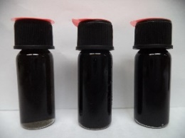 | 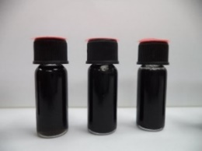 | 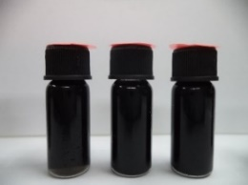 | 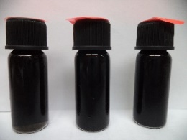
32 | 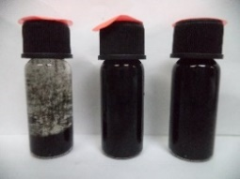 |  |  | 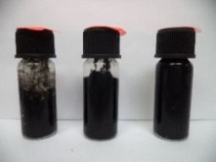
Figure 1 Visual photographs of glycerol DES nanolubricant samples with concentration of 0.01 wt% (left), 0.05 wt% (centre) and 0.10 wt% (right) of F-MWCNT for day 0 and Day 32
Day | DES 5 | DES 6 | DES 7
0 | 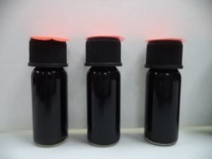 | 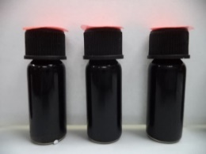 | 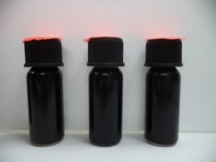
32
Figure 2 Visual photographs of PEG DES nanolubricant samples with concentration of 0.01 wt% (left), 0.05 wt% (centre) and 0.10 wt% (right) of F-MWCNT for day 0 and Day 32
3.1.2 Optical Microscopy
From Figure 3, it was found that as the concentration of F-MWCNT was increased the size of agglomerates increases for the nanolubricant samples. For the concentration of 0.01 wt%, the nanoparticle are dispersed in the base fluid with relatively spacing between the nanoparticles and smaller formation of clusters. As the concentration increases to 0.10 wt%, the space between the nanoparticles tend to decrease and the size of the cluster formation increases. The highest average cluster size was observed for sample NF 12 and the lowest average size of cluster was for NF 19. When the clusters are compared between the glycerol DES based nanolubricants and the PEG DES based nanolubricants, the PEG DES based nanolubricants were found to have lower cluster size and more dispersed. Therefore, PEG DES based naolubricant samples have better stability in comparison with glycerol DES based nanolubricant which was also supported by the results found in visual observation.

NF 1  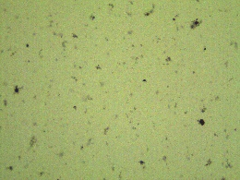  2.4 μm | NF 2  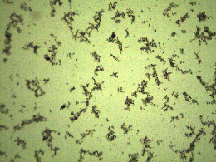  2.6 μm | NF 3  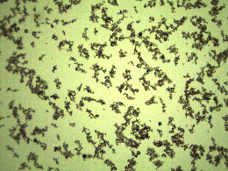  3.0 μm
NF 4  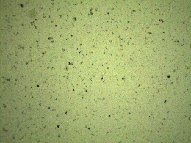  1.9 μm | NF 5  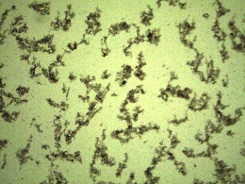  2.4 μm | NF 6  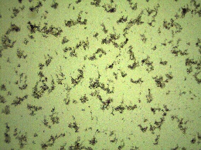  2.7 μm
NF 7  1.4 μm | NF 8  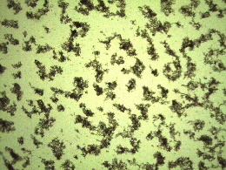  2.1 μm | NF 9  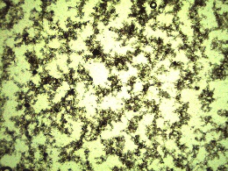  2.7 μm
NF 10  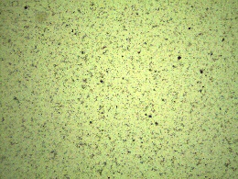  1.9 μm | NF 11  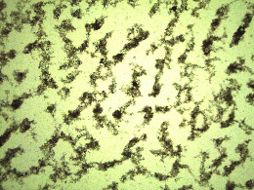  1.9 μm | NF 12  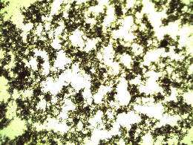  3.5 μm
NF 13  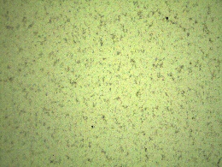  2.2 μm | NF 14  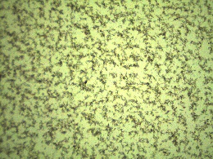  1.8 μm | NF 15  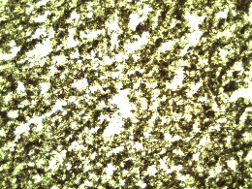  2.6 μm
NF 16  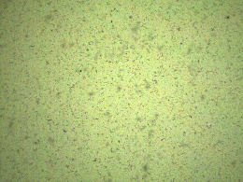  1.7 μm | NF 17  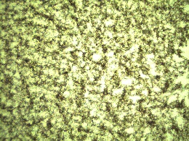  1.6 μm | NF 18  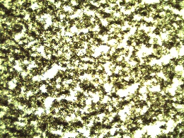  1.8 μm
NF 19  1.2 μm | NF 20  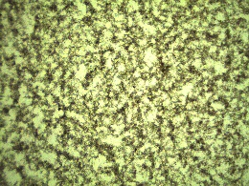  2.1 μm | NF 21  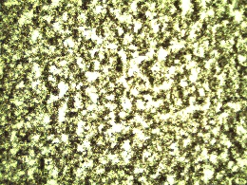  1.7 μm
Figure 3 Optical microscopy images of the nanolubricant samples
3.2 Density
The density of nanolubricant was investigated with increasing the concentration of F-MWCNT over a range of temperature. The density decreases linearly as the temperature increases for all the samples and the lowest density was obtained at the temperature 90°C. The increase in temperature leads to thermal expansion of the molecules resulting in reduction in density [23].
Most of the densities of DES 2, 3, 6 and 7 based nanolubricant showed very small variation with addition of F-MWCNT nanoparticles. Apparent increase of densities were observed for DES 1, DES 4 and DES 5 based nanolubricants over the range of temperature shown in Figure 4a, Figure 4d, and Figure 5a. The density of MWCNT nanoparticles are relatively higher and when added to the base fluid will increase the density of the nanofluid [23]. The addition of nanoparticles increases the density which is similar to MWCNT water-ethylene glycol nanofluid found by Kumaresan & Velraj [24] and also in MWCNT heat transfer oil nanofluid found by Fakoor et al [25] .
a) DES 1 based nanolubricants | b) DES 2 based nanolubricants
c) DES 3 based nanolubricants | d) DES 4 based nanolubricants
Figure 4 Density of a) DES 1 B) DES 2 c) DES 3 d) DES 4 based nanolubricants with respect to concentration of F-MWCNT at temperature of 25°C, 40°C and 90°C

a) DES 5 based nanolubricant |  | b) DES 6 based nanolubricant
 | c) DES 7 based nanolubricant
Figure 5 Density of a) DES 5 b) DES 6 c) DES 7 based nanolubricants with respect to concentration of F-MWCNT at temperature of 25°C, 40°C and 90°C

3.3 Viscosity
The addition of nanoparticles leads to certain enhancement of dynamic viscosity and the percentage enhancement of dynamic viscosity was calculated by using the Eq. 1 for temperature of 25°C, 40°C and 100°C.
$Enhancement of Dynamic Viscosity=\left( \frac{{μ_{nf - }μ}_{bf } }{μ_{bf}} \right) ×100\%$ (1)
Where,
μ_{nf =} dynamic viscosity of nanalubricant
μ_{bf} = dynamic viscosity of base fluid DES
From Figure 6 and Figure 7, the highest percentage of enhancement was obtain for concentration of F-MWCNT of 0.10 wt% at temperature of 100°C. The highest enhancement for concentration of 0.10 wt% F-MWCNT was obtained at 255.3% for NF 12 sample and the lowest enhancement at 44.8% for NF 6 sample at 100°C. For some of the samples with concentration of 0.01 wt% and 0.05 wt% there were negative enhancement for temperature of 25°C and 40°C but eventually at 100°C the enhancement becomes positive. At lower concentration of F-MWCNT, the dynamic viscosity of the nanolubricant samples were lower than the base fluids due to self-lubricating effect of the nanoparticles that results in negative enhancement [26]. The highest percentage enhancement for concentration of 0.01 wt% was for sample NF 19 with 11.3% at 100°C.
It can be concluded that higher the concentration of F-MWCNT, higher enhancement of dynamic viscosity occurs. Similar enhancement was reported by Halelfadl et al. [27] on CNT/water nanofluids and observed six fold increase in viscosity compared to the base fluid. Another study reports significant increase in relative viscosity when the volume fraction of CNT was increased above 0.055% [28]. The viscosity of the nanofluid increases non-linearly as the concentration of F-MWCNT increases due to increment of internal viscous shear stress. The structure of nanoparticle increases the surface interaction when dispersed in a base fluid which leads to enhancement of dynamic viscosity. When the temperature was increased, the dynamic viscosity of nanofluid also decreases similar to that of the base fluid (DES) due to the weakening of intermolecular forces of F–MWCNT at elevated temperatures [26].
a) DES 1 based nanolubricant | b) DES 2 based nanolubricant
c) DES 3 based nanolubricant | d) DES 4 based nanolubricant
Figure 6 Percentage enhancement in Dynamic Viscosity of a) DES 1 b) DES 2 c) DES 3 d) DES 4 based nanolubricants with respect to concentration of F-MWCNT at temperature of 25°C, 40°C and 100°C

a) DES 5 based nanolubricant |  | b) DES 6 based nanolubricant
 | c) DES 7 based nanolubricant
Figure 7 Percentage enhancement in Dynamic Viscosity of a) DES 5 b) DES 6 c) DES 7 based nanolubricants with respect to concentration of F-MWCNT at temperature of 25°C, 40°C and 100°C

3.4 Thermal Conductivity
The percentage enhancement of thermal conductivity was investigated using the Eq. 2 [26]
$Thermal conductivity enhancement= \left(\frac{k_{nf}-k_{bf}}{k_{bf}}\right)$ (2)
Where
k_{nf} = thermal conductivity of nanolubricant
k_{bf} = thermal conductivity of nanolubricant

From Figure 8, positive enhancement was observed for all the samples with the highest percentage enhancement in thermal conductivity demonstrated by 0.10 wt% of F-MWCNT. The highest enhancement was found for NF 12 sample with 8.37% at 60°C and the lowest enhancement was 0.41% for NF 7 at temperature of 25°C. Similar results were reported by Ding et al. [29] for CNT in distilled water, Phuoc et al. [30] for MWCNT in deionised water with chitosan and Kumaresan & Velraj [24] for MWCNT in ethylene glycol-water nanofluid. It can be concluded that increasing the concentration of MWCNT increases the thermal conductivity as more heat was transferred through the nanoparticles [27]. The MWCNT have high thermal conductivity well above 2000 W/m.K and high aspect ratio which makes the MWCNT nanofluids excellent heat transfer liquids. The enhanced thermal conductivity of nanofluids are contributed by the nature of the heat conduction in the MWCNT suspension and the organised structure at the solid/liquid interface [31].
From Figure 9, an opposite behaviour was observed compared to glycerol DES based nanolubricant in Figure 8. The PEG DES based nanolubricant exhibit negative enhancement which means the addition of nanoparticles decreases the thermal conductivity of the samples. Only sample NF 15 and NF 18 showed positive value of 0.2% and 0.5% respectively at 100°C. Other than that, negative enhancement was obtained for the other samples and temperature with highest negative enhancement being -4.5% for NF 20 sample at 60°C. The nanoparticles moving randomly and colliding in the base fluid is known as Brownian motion. Brownian motion plays an important role in enhancement of thermal conductivity when the two particles collide there is solid-solid heat transfer taking place or heat transfer by diffusion. Stoke-Einstein equation is used to express the diffusion constant [32]. There is an increase in viscosity for pure PEG with the formation of DES due to bonding of the three component DES which lead to the negative enhancement as the Brownian motion interrupted.

a) DES 1 based nanolubricamt | b) DES 2 based nanolubricant
c) DES 3 based nanolubricant | d) DES 4 based nanolubricant
Figure 8 Percentage enhancement of thermal conductivity of glycerol DES based nanolubricants with respect to concentration of F-MWCNT at temperature of 25°C, 40°C and 60°C

a) DES 5 based nanolubricant |  | b) DES 6 based nanolubricant
 | c) DES 7 based nanolubricant
Figure 9 Percentage enhancement of thermal conductivity of PEG DES based nanolubricants with respect to concentration of F-MWCNT at temperature of 25°C, 40°C and 60°C

4. Conclusion
The potential of nanolubricants are vibrantly being explored as the future of the lubrication industry. The formation of glycerol and PEG 600 based DES with choline chloride salt as the base fluid for the nanolubricant. The addition of F-MWCNT with three different concentration were found to be stable and even the nanoparticle tends to sediment, the nanolubricant can easily dispersed with simple shaking of the samples. The PEG DES based nanolubricant showed better stability and smaller agglomerate size than the glycerol DES based nanolubricant. The density decreases as the temperature increases and most of the sample showed very less variation with the addition of F-MWCNT. Similarly, the dynamic viscosity also decreases with increasing temperature and the addition of F-MWCNT effected the resultant viscosity. The highest enhancement of viscosity was found for concentration of 0.1 wt% F-MWCNT with 255.3% for glycerol DES nanolubricant and 104.5% for PEG DES based nanolubricant. Viscosity plays a vital role when it comes to lubrication and the viscosity of the nanolubricants were found to be sufficient to function as lubricant when compared with other commercial lubricants. Besides that, the glycerol DES based nanolubricant showed positive enhancement of thermal conductivity whereas the PEG DES based nanolubricant showed negative enhancement. The enhancement either positive or negative could be useful when the nanolubricant were specified for certain lubricant application. Nevertheless, more extensive and vigorous research need to be conducted for better understanding of DES-CNT nanolubricants as industrial application. There are a lot of potential of the DES base fluid and nanoparticle combination.

5. References

[1] R. Mortier, M. Fox, and S. Orszulik, Chemistry and technology of lubricants, vol. 53. Dordrecht: Springer, 2010.
[2] G. W. Stachowiak and A. W. Batchelor, Engineering tribology. Amsterdam: Elsevier, 2005.
[3] D. Pirro, “Lubrication Fundamentals,” in Comprehensive Review of Lubricant Chemistry, Technology, Selection, and Design, pp. 1–22, 2001.
[4] J. Qu, H. Luo, M. Chi, C Ma, P. J. Blau, S. Dai, and M. B Viola, Comparison of an oil-miscible ionic liquid and ZDDP as a lubricant anti-wear additive. Tribology International, 71, 88–97, 2014.
[5] B. Khemchandani, A. Somers, P. Howlett, K. Jaiswal, E. Sayanna, and M. Forsyth, A biocompatible ionic liquid as an antiwear additive for biodegradable lubricants. Tribology International, 77, 171–177, 2014.
[6] X. Fan, and L. Wang, Ionic liquids gels with in situ modified multiwall carbon nanotubes towards high-performance lubricants. Tribiology International, 88, 179–188, 2015.
[7] M. Anand, M. Hadfield, J. L. Viesca, B. Thomas, Hernández Battez, and S. Austen, Ionic liquids as tribological performance improving additive for in-service and used fully-formulated diesel engine lubricants. Wear, 334–335, 67–74, 2015.
[8] A. García, R. González, Hernández Battez, J. L Viesca, R. Monge, Fernández-González, and M. Hadfield, M, Ionic liquids as a neat lubricant applied to steel-steel contacts. Tribology International, 72, 42–50, 2014.
[9] Y. Kondo, T. Koyama, and S. Sasaki, Tribological Properties of Ionic Liquids, Ionic Liquids - New Aspects for the Future, Dr. Jun-ichi Kadokawa (Ed.), InTech, DOI: 10.5772/52595, 2013.
[10] M. Q. Pham, H.S. Yoon, V. Khare, and S. H. Ahn, Evaluation of ionic liquids as lubricants in micro milling - Process capability and sustainability. Journal of Cleaner Production, 76, 167–173, 2014.
[11] B. Tang, H. Zhang, and K. H. Row, “Application of deep eutectic solvents in the extraction and separation of target compounds from various samples,” J. Sep. Sci., vol. 38, pp. 1053–1064, 2015.
[12] Y. Y. Wu, W. C. Tsui, and T. C. Liu, “Experimental analysis of tribological properties of lubricating oils with nanoparticle additives,” Wear, vol. 262, no. 7–8, pp. 819–825, 2007.
[13] T. Luo, X. Wei, H. Zhao, G. Cai, and X. Zheng, “Tribology properties of Al2O3/TiO2 nanocomposites as lubricant additives,” Ceram. Int., vol. 40, no. 7, pp. 10103–10109, 2014.
[14] K. Lee, Y. Hwang, S. Cheong, L. Kwon, S. Kim, and J. Lee, “Performance evaluation of nano-lubricants of fullerene nanoparticles in refrigeration mineral oil,” Curr. Appl. Phys., vol. 9, no. 2 SUPPL., pp. e128–e131, 2009.
[15] Ko, G. W., Heo, K., Lee, K., & Choi, M. (2007). Thermal and Flow Characteristics of Carbon Nanotube Nanofluids. International Congress for Particle Technology, Partec, 151-742.
[16] Joly-Pottuz, L. and Ohmae, N. (2008) Carbon-Based Nanolubricants, in Nanolubricants (eds J. M. Martin and N. Ohmae), John Wiley & Sons, Ltd, Chichester, UK.
[17] Luo, T., Wei, X., Zhao, H., Cai, G., & Zheng, X. (2014). Tribology properties of Al₂O₃/TiO₂ nanocomposites as lubricant additives. Ceramics International, 40(7), 10103–10109.
[18] W. Rashmi, M. Khalid, S. S. Ong, and R. Saidur, “Preparation, thermo-physical properties and heat transfer enhancement of nanofluids,” Mater. Res. Express, vol. 1, no. 3, p. 32001, 2014.
[19] E. L. Smith, A. P. Abbott, and K. S. Ryder, “Deep Eutectic Solvents (DESs) and Their Applications,” Chem. Rev., vol. 114, no. 21, pp. 11060–11082, 2014.
[20] Y. Dai, J. Van Spronsen, G. J. Witkamp, R. Verpoorte, and Y. H. Choi, “Ionic liquids and deep eutectic solvents in natural products research: Mixtures of solids as extraction solvents,” J. Nat. Prod., vol. 76, no. 11, pp. 2162–2173, 2013.
[21] G. Garcia, S. Aparicio, R. Ullah, and M. Atilhan, “Deep Eutectic Solvents: Physicochemical Properties and Gas Separation Applications,” Energy & Fuels, vol. 29, pp. 2616–2644, 2015.
[22] B. Lamas, B. Abreu, A. Fonseca, N. Martins, and M. Oliveira, “Assessing colloidal stability of long term MWCNT based nanofluids,” J. Colloid Interface Sci., vol. 381, no. 1, pp. 17–23, 2012.
[23] R. B. Leron, D. S. H. Wong, and M.-H. Li, “Densities of a deep eutectic solvent based on choline chloride and glycerol and its aqueous mixtures at elevated pressures,” Fluid Phase Equilib., vol. 335, pp. 32–38, 2012.
[24] V. Kumaresan and R. Velraj, “Experimental investigation of the thermo-physical properties of water-ethylene glycol mixture based CNT nanofluids,” Thermochim. Acta, vol. 545, pp. 180–186, 2012.
[25] M. Fakoor Pakdaman, M. A. Akhavan-Behabadi, and P. Razi, “An experimental investigation on thermo-physical properties and overall performance of MWCNT/heat transfer oil nanofluid flow inside vertical helically coiled tubes,” Exp. Therm. Fluid Sci., vol. 40, pp. 103–111, 2012.
[26] L. Chen, H. Xie, W. Yu, and Y. Li, “Rheological Behaviors of Nanofluids Containing Multi-Walled Carbon Nanotube,” J. Dispers. Sci. Technol., vol. 32, no. 4, pp. 550–554, 2011.
[27] S. Halelfadl, P. Estell, B. Aladag, N. Doner, T. Mar, S. Halelfadl, P. Estell, B. Aladag, N. Doner, and T. Mar, “Viscosity of carbon nanotubes water based nanofluids : Influence of concentration and temperature To cite this version :,” 2013.
[28] S. Halelfadl, T. Maré, and P. Estellé, “Efficiency of carbon nanotubes water based nanofluids as coolants,” Exp. Therm. Fluid Sci., vol. 53, pp. 104–110, 2014.
[29] Y. Ding, H. Alias, D. Wen, and R. a. Williams, “Heat transfer of aqueous suspensions of carbon nanotubes (CNT nanofluids),” Int. J. Heat Mass Transf., vol. 49, no. 1–2, pp. 240–250, 2006.
[30] T. X. Phuoc, M. Massoudi, and R. H. Chen, “Viscosity and thermal conductivity of nanofluids containing multi-walled carbon nanotubes stabilized by chitosan,” Int. J. Therm. Sci., vol. 50, no. 1, pp. 12–18, 2011.
[31] M.-S. Liu, M. Ching-Cheng Lin, I.-T. Huang, and C.-C. Wang, “Enhancement of thermal conductivity with carbon nanotube for nanofluids,” Int. Commun. Heat Mass Transf., vol. 32, no. 9, pp. 1202–1210, 2005.
[32] K. P. Reddy, B. Panitapu, and G. A. Reddy, “Nano Fluids and Heat Transfer Enhancement a Review,” vol. 7, no. 6, 2016.

